

**Web Design and Development**

**4COSC011W**

**Report**

**Author: Maduri Dhananjani**

**Student ID: 20200652**

**Group Number: M2**

**Student Role: Student 3**

<https://w1870614.users.ecs.westminster.ac.uk/>

List of figures 3

1.Introduction 5

2. Technical Discussion 9

23

24

3. Webpage Validation Statement 28

4. Janet 29

Appendices 31

Appendix A: Code 31

Appendix B: Screenshots 49

Appendix C: Screenshots - Webpage Validation Evidence 60

Appendix D: Individual Statement 61

List of figures

**Figure 1 logo** 5

**Figure 2 Quiz rules** 11

**Figure 3 button style** 11

**Figure 4 Quiz start** 12

**Figure 5 question 1-2** 13

**Figure 6 quiz questions** 13

**Figure 7 timer** 13

**Figure 8 question 3-4** 14

**Figure 9 question 5-6** 14

**Figure 10 question 7-8** 15

**Figure 11 question 9-10** 15

**Figure 12 quiz end** 16

**Figure 13 quiz js 1** 16

**Figure 14 quiz js 2** 17

**Figure 15 BG color Red** 17

**Figure 16 BG color green** 18

**Figure 17 BG color yellow** 18

**Figure 18 SD 1** 19

**Figure 19 SD 2** 19

**Figure 20 SD 4** 20

**Figure 21 SD 3** 20

**Figure 22 Page Editor 1** 21

**Figure 23 Page Editor 2** 21

**Figure 24 Page Editor 3** 22

**Figure 25 Home 1** 23

**Figure 26 Home 2** 23

**Figure 27 Home 4** 24

**Figure 28 Home 3** 24

**Figure 29 Additional one** 27

**Figure 30 Quiz 1** 49

**Figure 31 Quiz 2** 49

**Figure 32 Quiz 3** 50

**Figure 33 Quiz 4** 50

**Figure 34 Quiz 5** 51

**Figure 35 Quiz 6** 51

**Figure 36 Quiz 7** 52

**Figure 37 Quiz 8** 52

**Figure 38 Quiz 9** 53

**Figure 39 Quiz 10** 53

**Figure 40 Student Details 1** 54

**Figure 41 Student Details 2** 54

**Figure 42 Student Details 3** 55

**Figure 43 Student Details4** 55

**Figure 44 Page Editor** 56

**Figure 45 Main Page 1** 57

**Figure 46 Main Page 2** 57

**Figure 47 Main Page 3** 58

**Figure 48 Main Page 4** 58

**Figure 49 Main Page 6** 59

**Figure 50 Main Page 5** 59

**Figure 51 Validator 1** 60

**Figure 52 Validator 2** 60

1.Introduction

Subject: SPORTS

Our name of the website: Mr. Cricket

**Mr. Cricket**



**Logo**

**Figure 1 logo**

**Team members**

|  |  |  |
| --- | --- | --- |
| **Name** | **Role number** | **Task** |
| Chamelee Gurusinghe | Student 1 | Presentation page  Buy Products |
| Maneesha Shehara | Student 2 | Main page and external CSS  Query Form |
| Maduri Dhananjani | Student 3 | Quiz  Student Details |
| Praveen Navanjana | Student 4 | Diagram (SVG)  Thumbnail Images |

| **Group Coursework Meetings** | | |
| --- | --- | --- |
| **1** | **Date & Time** | 12 March 2022 |
| **Objective** | Selecting topics |
| **Attended** | All four attended |
| **Your Contribution** | Suggested the sports theme for the topics |
| **2** | **Date & Time** | 15 March 2022 |
| **Objective** | Divide the work |
| **Attended** | All four attended |
| **Your Contribution** | chose to be student 3 depicted in the coursework |
| **3** | **Date & Time** | 18 March 2022 |
| **Objective** | Chose the structure |
| **Attended** | All four Attended |
| **Your Contribution** | Suggest the structure |
| **4** | **Date & Time** | 20 March 2022 |
| **Objective** | choosing a theme |
| **Attended** | All four attended |
| **Your Contribution** | colors recommended for subjects and hover |
| **5** | **Date & Time** | 22 March 2022 |
| **Objective** | design a logo |
| **Attended** | All four attended |
| **Your Contribution** | color suggestions for the logo |
| **6** | **Date & Time** | 27 March 2022 |
| **Objective** | making a home page |
| **Attended** | All four attended |
| **Your Contribution** | Creating a ranking table |
| **7** | **Date & Time** | 28 March 2022 |
| **Objective** | Creating an additional page |
| **Attended** | All four attended |
| **Your Contribution** | creating T20I table |
| **8** | **Date & Time** | 29 March 2022 |
| **Objective** | finalizing our work |
| **Attended** | All four attended |
| **Your Contribution** | Discuss how to submit our works |

2. Technical Discussion

Because everyone on the team plays cricket, the team decided to establish a cricket website. We spoke about a color theme and an approach throughout the development process since we wanted the website to be user pleasant and entertaining. We decided on a single theme and built the navigation bar and footer, which must appear on all pages.

1. Quiz

2. Student Details

3. Page Editor

**1.QUIZ**

First, I select the questions for the quiz. I got these questions and answers from the internet.

And I made these questions

1) In Which year did Sri Lanka first win an Asia cup away from home?

a. "1986",

b. "2001",

c. "2013",

d. "2008",

correct: "d"

2) Which Sri Lanka won player of the series award in the 1996 ICC world cup?

a. "Chaminda vas",

b. "Aravinda Silva",

c. "Sanath Jayasuriya",

d. "Muttiah Muralidharan",

correct: "c",

3) Who was Sri Lankan first test captain?

a. "Chaminda vas",

b. "Bandula warnapura",

c. "Sanath Jayasuriya",

d. "Muttiah Muralidharan",

correct: "b",

4) who was the first Sri Lanka bowler to take a hat-trick in test cricket?

a. "Chaminda vas",

b. "Nuwan Zoysa",

c. "Sanath Jayasuriya",

d. "Muttiah Muralidharan",

correct: "b",

5)which Sri Lankan family produced 3 test-playing brothers?

a. "De silva",

b. "Ranatunga",

c. "Sanath Jayasuriya",

d. "Jayawardana",

correct: "b"

6) What is the oldest cricket club in Sri Lanka?

a. "Galle cricket club",

b. "Colombo cricket club",

c. "Bloomfield cricket club",

d. "Sinhalese Sports club",

correct: "b"

7)Sri Lankan first official international match was played in 1975.

a. “True”

b. “False”

correct: “a”

8) which Sri Lankan cricketer captained the team the most times?

a. "Mahela Jayawardana",

b. "Arjuna Ranathunga",

c. "Thilakaratne Dilshan",

d. "Sanath Jayasuriya",

correct: "b"

9)which Player scored Sri Lankan T20I century?

a. "Mahela Jayawardana",

b. "Arjuna Ranathunga",

c. "Thilakaratne Dilshan",

d. "Sanath Jayasuriya",

correct: "a"

10)who scored Sri Lankan first test century?

a. "Duleep Mendis ",

b. "Ranjan Madugalla",

c. "Sidath Wettimuny",

d. "Sanath Jayasuriya",

correct: "b",

Inside a division tag <div>, I created guidelines for the quiz questions. And I used CSS to create a start button for going to the quiz questions.

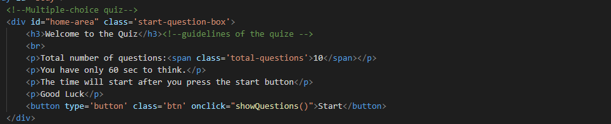

**Figure 2 Quiz rules**

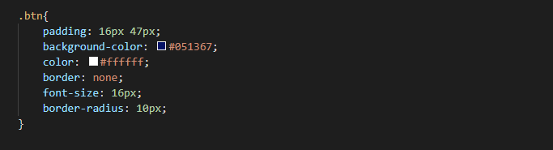

**Button Style**

**Figure 3 button style**

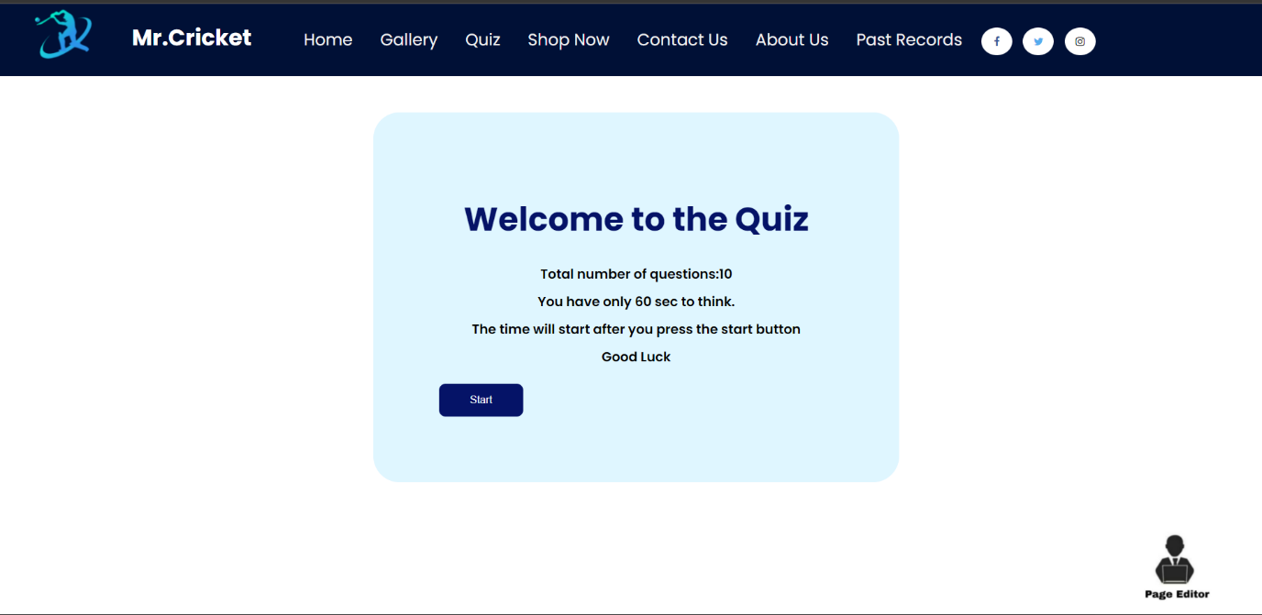

**Figure 4 Quiz start**

**Quiz Start**

The user can then go to the quiz questions by hitting the "START" button.

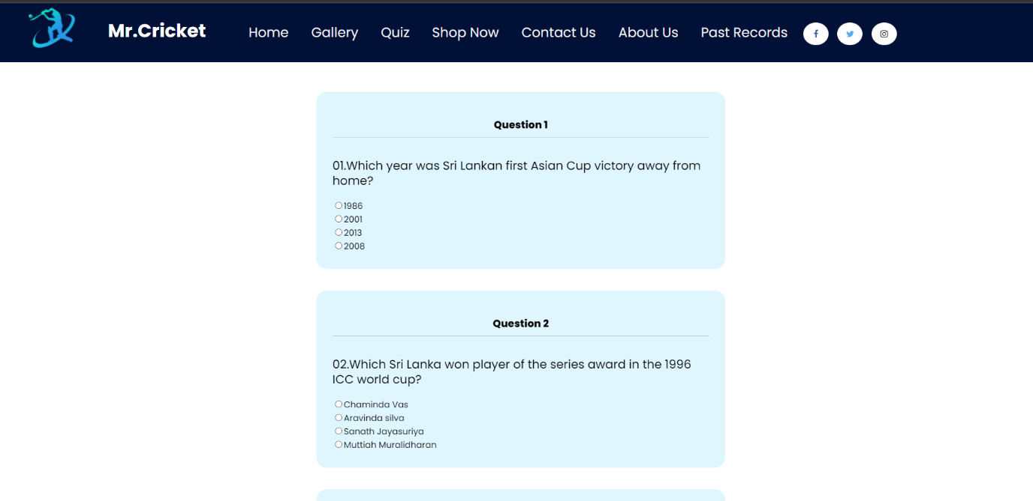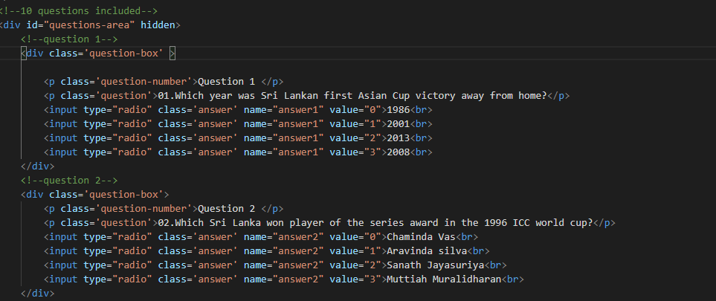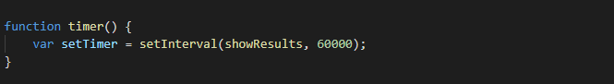There are ten quiz questions. I was answering the quiz with the radio buttons. I was given one minute to complete the task.

**Question1-2**

**Figure 5 question 1-2**

**Quiz Questions**

**Figure 6 quiz questions**

**Timmer**

**Figure 7 timer**

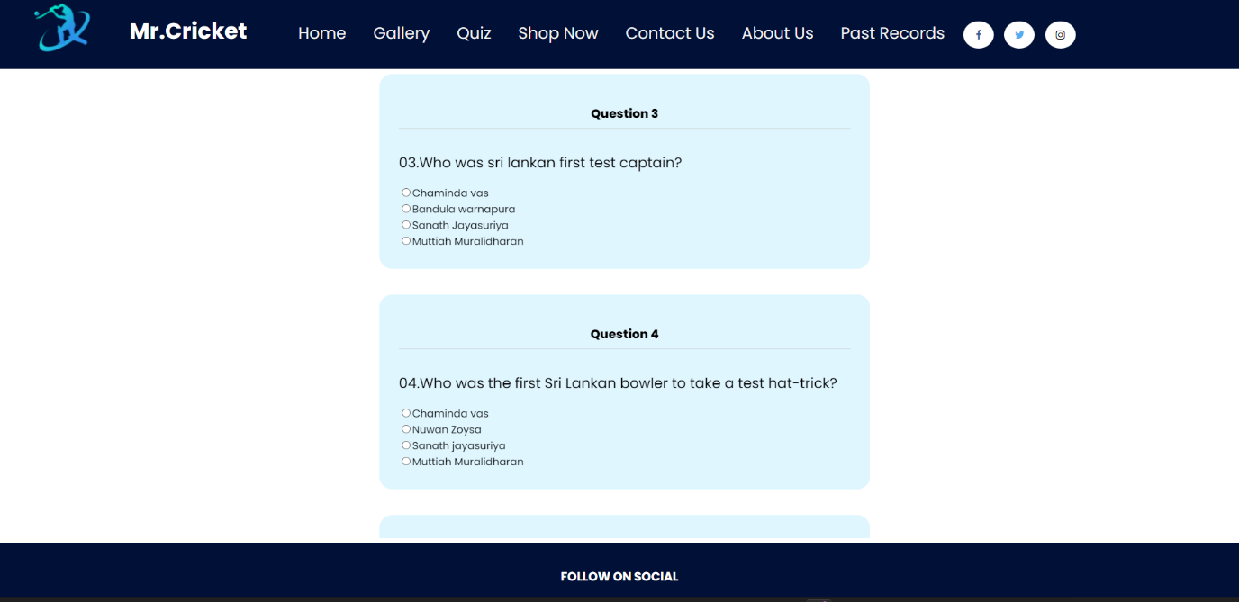

**Question 3-4**

**Figure 8 question 3-4**

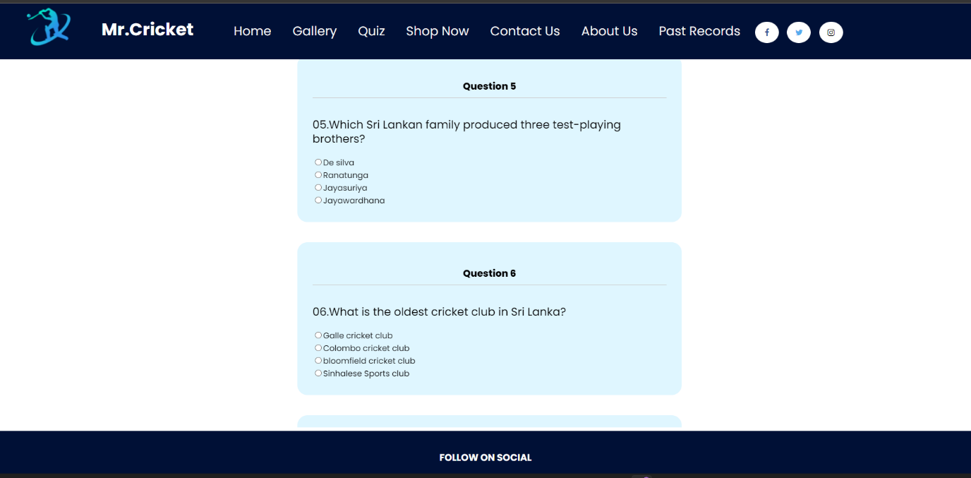

**Question 5-6**

**Figure 9 question 5-6**

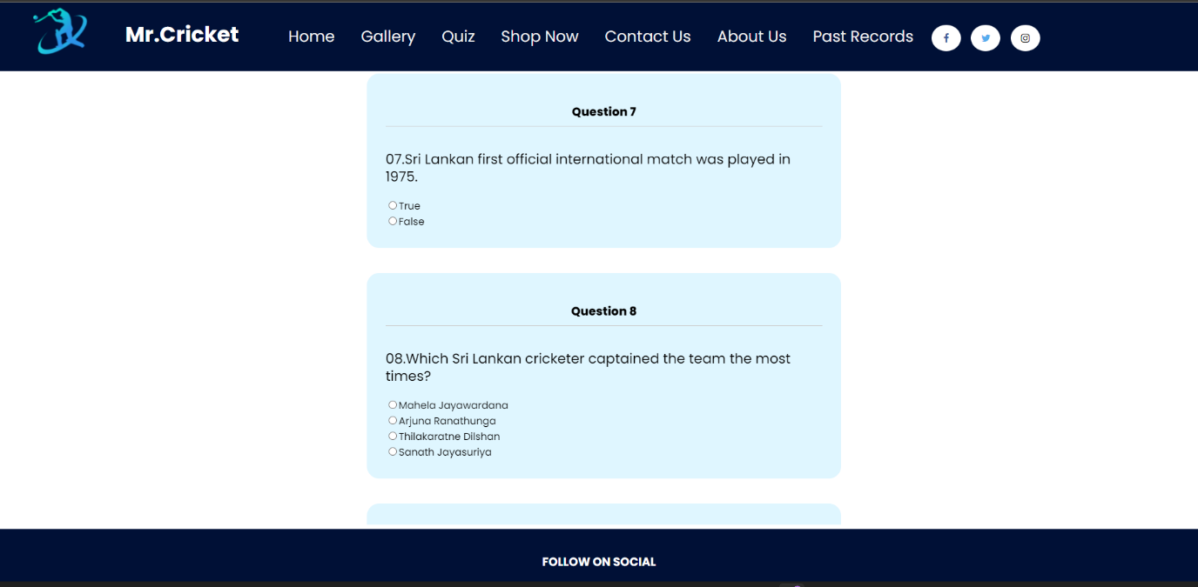

**Figure 10 question 7-8**

**Question 7-8**

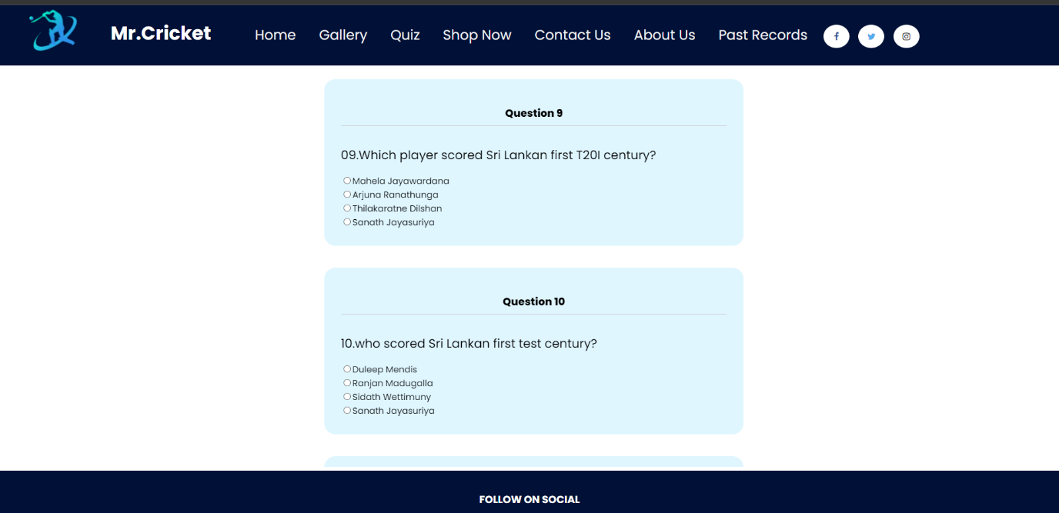

**Question 9-10**

**Figure 11 question 9-10**

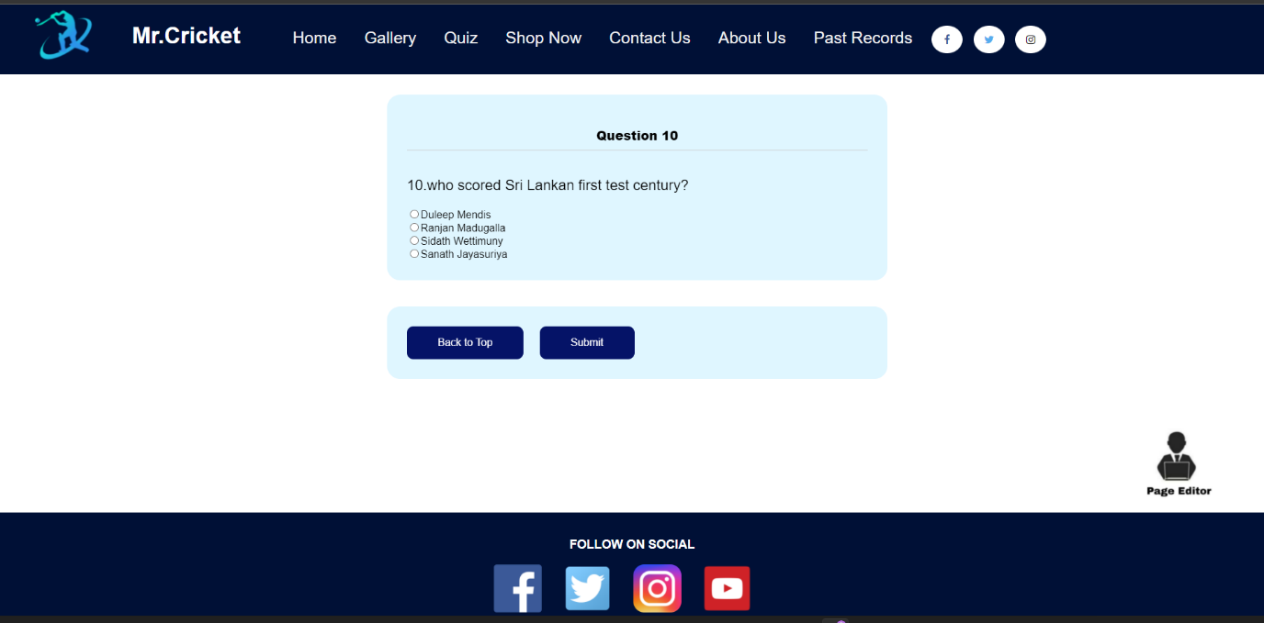

**Quiz end**

**Figure 12 quiz end**

After one minute, it turns off and displays the user's result. The results display the user's total score, questions for which the user-submitted correct answers, and questions for which the user entered erroneous responses.

The user will get 2 marks for each correct answer, and -1 for each wrong answer.

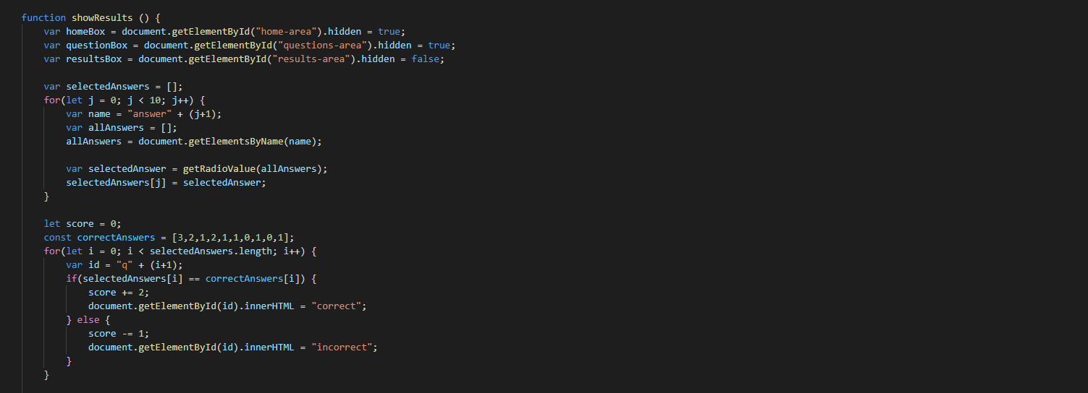

**Quiz JS 1**

**Figure 13 quiz js 1**

If the user gets results from 1-4, the background color changes to RED.

If the user gets results from 5-16, the background color changes to YELLOW.

If the user gets results from 17-20, the background color changes to GREEN.

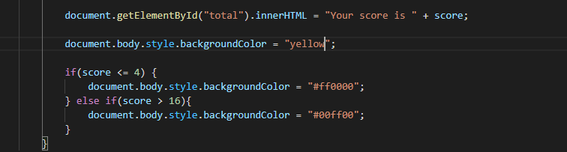

**Quiz JS 2**

**Figure 14 quiz js 2**

And the user can’t retry the quiz.

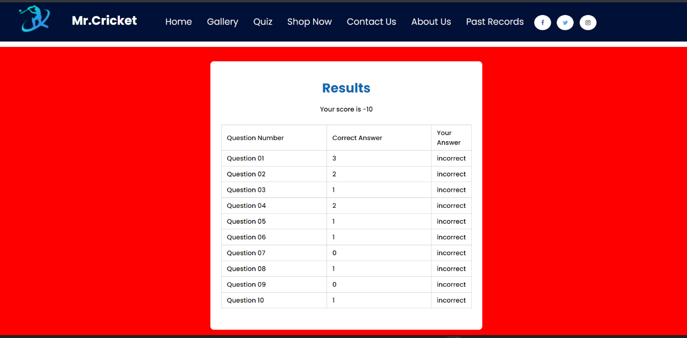

**BG Color Red**

**Figure 15 BG color Red**

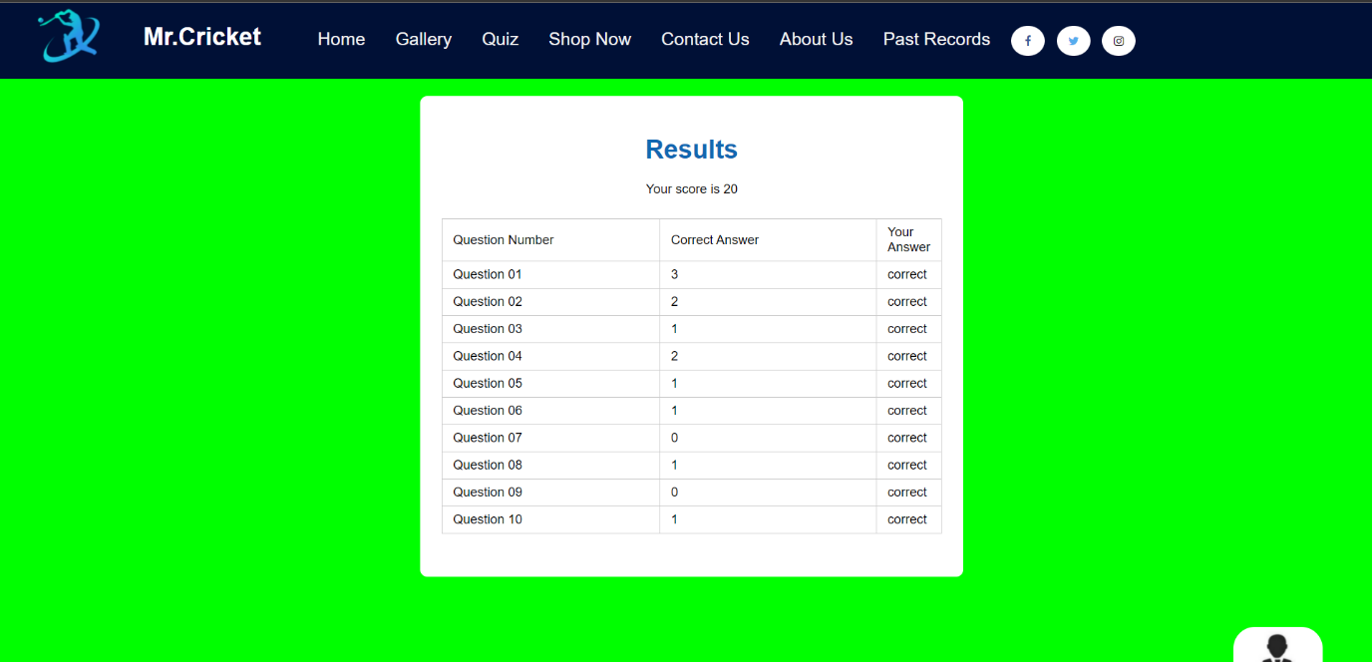

**BG color green**

**Figure 16 BG color green**

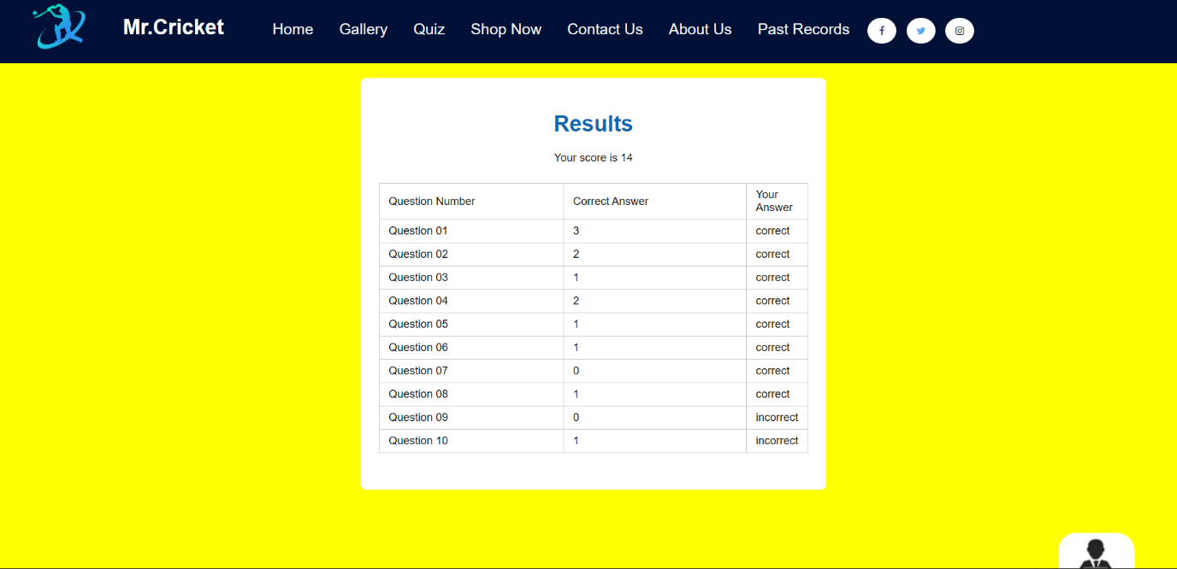

**BG color yellow**

**Figure 17 BG color yellow**

**2. Student details**

Student details page,

The viewer can see four photographs of our group members.

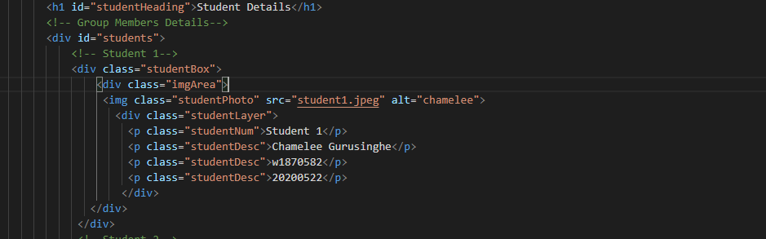

**SD 1**

**Figure 18 SD 1**

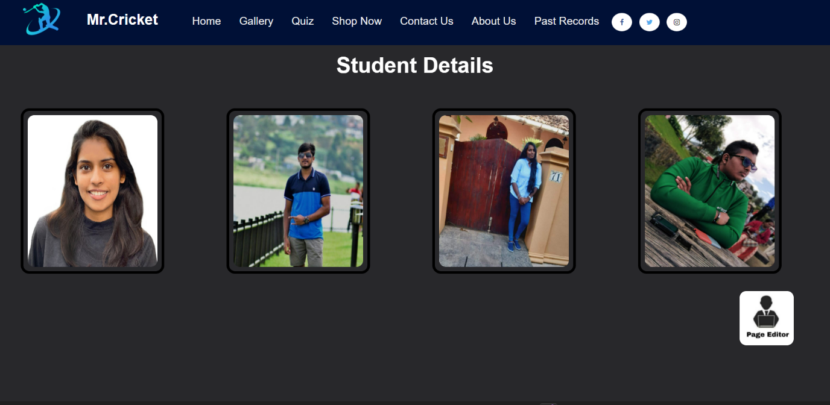

**SD 2**

**Figure 19 SD 2**

When the user moves the mouse over the image, the member’s information is displayed.

The details include the name, UoW number, IIT number, and student number of the role

**SD 3**

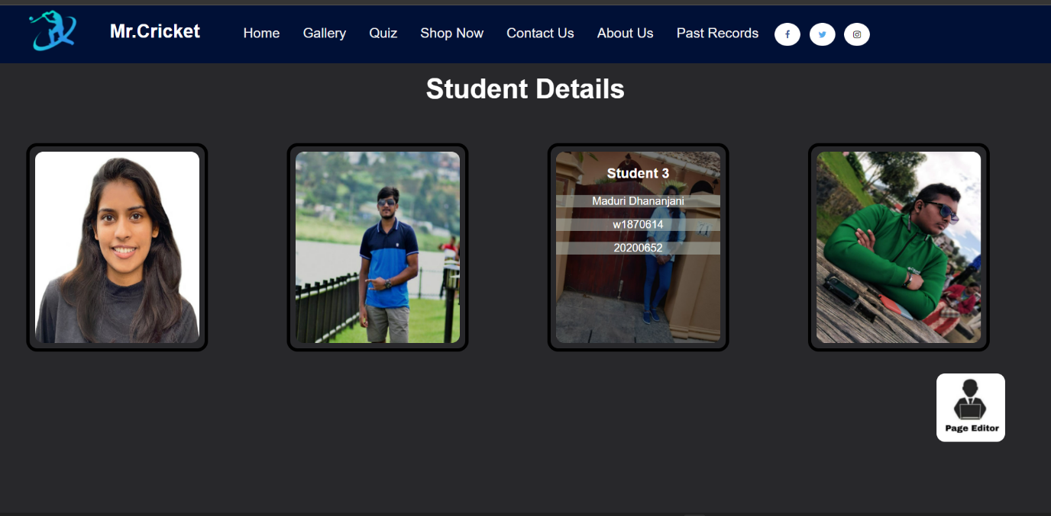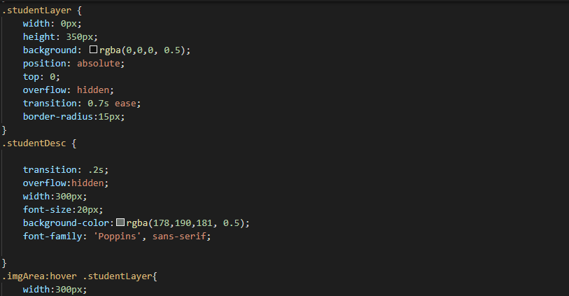

**SD 4**

**Figure 20 SD 4**

**Figure 21 SD 3**

**3. Page Editor**

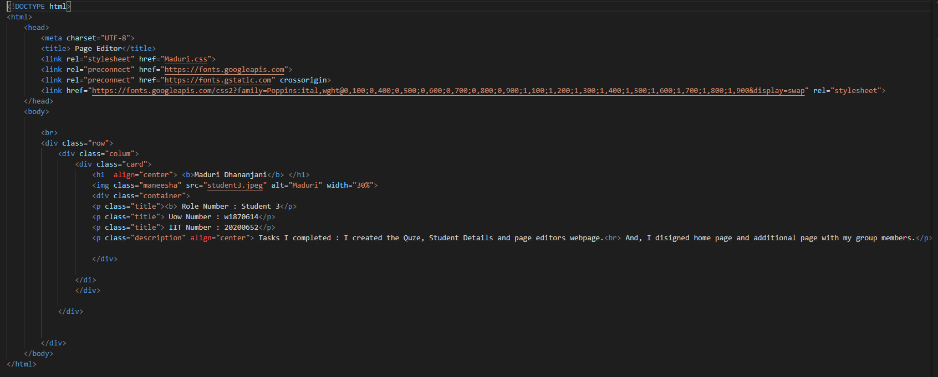The editor page shows my details about this website**.**

**Figure 22 Page Editor 1**

**Page Editor 1**

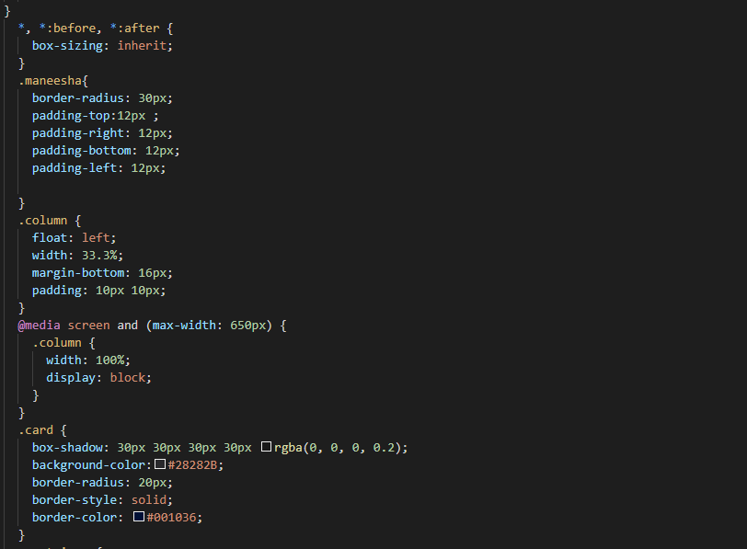

**Page Editor 2**

**Figure 23 Page Editor 2**

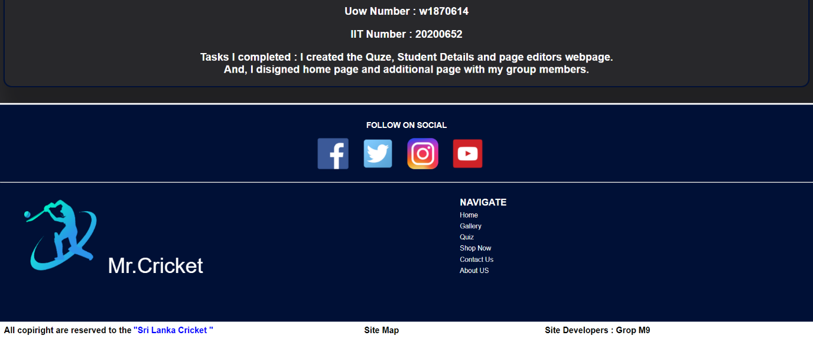

**Page Editor 3**

**Figure 24 Page Editor 3**

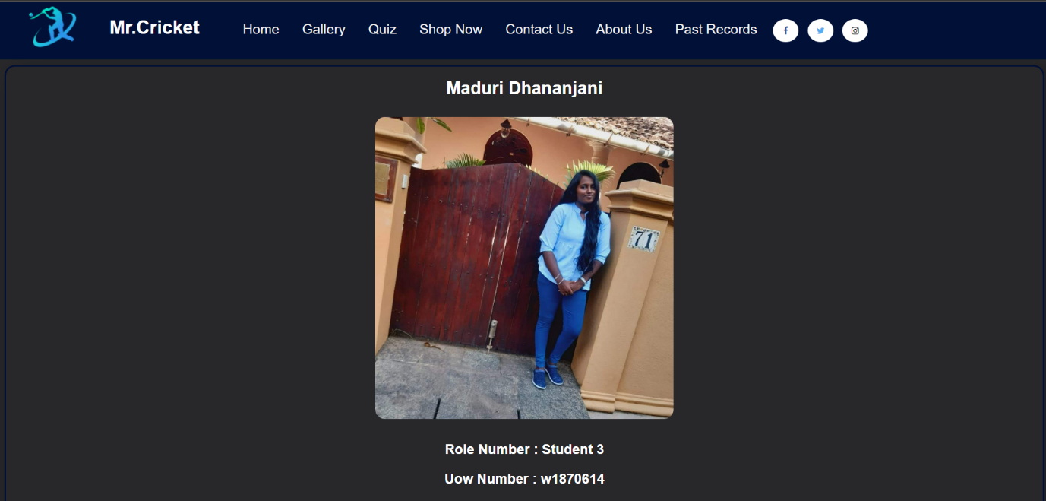

Challenges faced during development:

The most difficult part for me was planning the logic for the JavaScript used to create the quiz. The other was arranging the images of all four students in a row. As a result, I watched several YouTube videos and listened to lecture notes. Then, once I completed the tasks effectively, I became mired in difficulties.

**4. Home page**

I created ICC rankings part of the home page

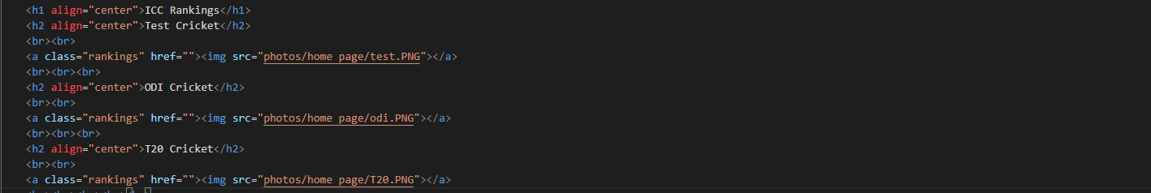

**Home 1**

**Figure 25 Home 1**

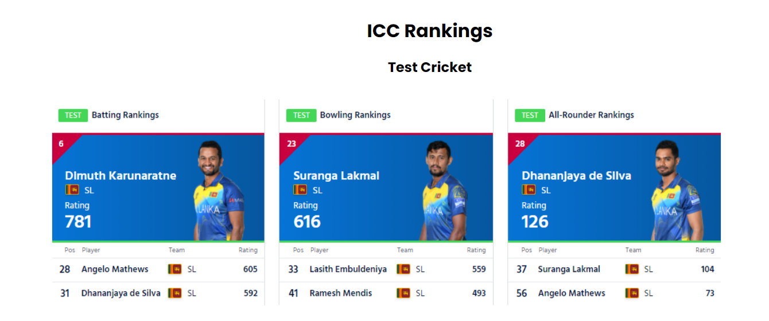

**Figure 26 Home 2**

**Home 2**

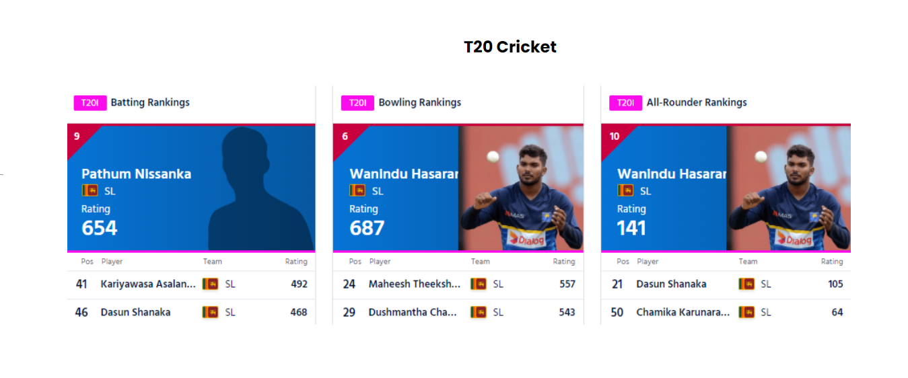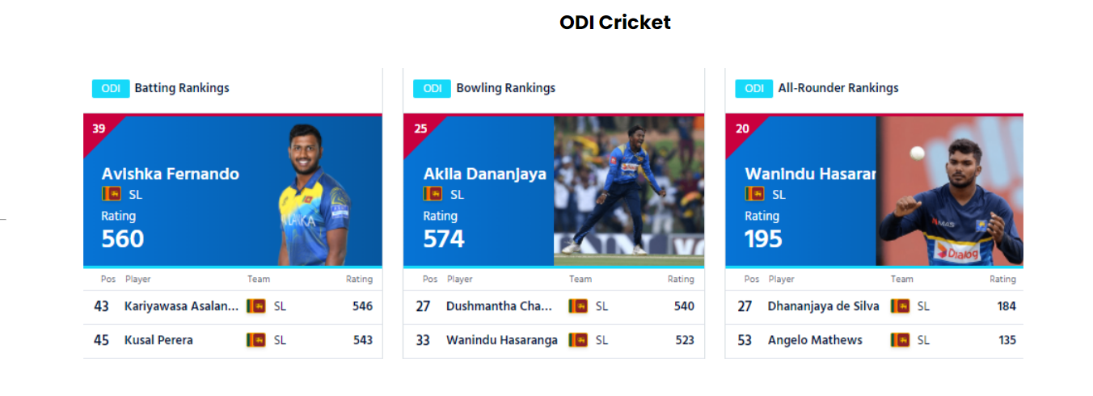

**Home 4**

**Figure 27 Home 4**

**Home 3**

**Figure 28 Home 3**

**5. Additional Page**

I created a T20I cricket table for the additional page.

<div class="table_responsive">

        <h1>T20I Cricket</h1>

        <table>

          <thead>

            <tr align="center">

              <th>Number</th>

              <th>Image</th>

              <th>Name</th>

              <th> Most Runs</th>

            </tr>

          </thead>

          <tbody>

            <tr class="tabletop" align="center">

              <td>01</td>

              <td><img src="photos/additional page/dilshan.webp" alt="Tillakarathne Dilshan"></td>

              <td>Tillakarathne Dilshan</td>

              <td>1889</td>

              </td>

            </tr>

            <tr align="center">

              <td>02</td>

              <td><img src="photos/additional page/kusal.webp" alt="Kusal Perera"></td>

              <td>Kusal Perera</td>

              <td>1539</td>

            </tr>

            <tr align="center">

              <td>03</td>

              <td><img src="photos/additional page/mahela.webp" alt="Mahela Jayawardene"></td>

              <td>Mahela Jayawardene</td>

              <td>1493</td>

            </tr>

            <tr align="center">

                <td>04</td>

                <td><img src="photos/additional page/sangakkara.webp" alt="Kumar Sangakkara"></td>

                <td>Kumar Sangakkara</td>

                <td>1382</td>

            </tr>

            <tr align="center">

                <td>05</td>

                <td><img src="photos/additional page/angelo.webp" alt="Angelo Mathews"></td>

                <td>Angelo Mathews</td>

                <td>6361</td>

            </tr>

          </tbody>

        </table>

        <table>

            <thead>

              <tr>

                <th>Number</th>

                <th>Image</th>

                <th>Name</th>

                <th>Most Wickets</th>

              </tr>

            </thead>

            <tbody>

              <tr class="tabletop" align="center">

                <td>01</td>

                <td><img src="photos/additional page/malinga.webp" alt="Lasith Malinga"></td>

                <td>Lasith Malinga</td>

                <td>107</td>

                </td>

              </tr>

              <tr align="center">

                <td>02</td>

                <td><img src="photos/additional page/ajantha.webp" alt="Ajantha Mendis"></td>

                <td>Ajantha Mendis</td>

                <td>66</td>

              </tr>

              <tr align="center">

                <td>03</td>

                <td><img src="photos/additional page/nuwan.webp" alt="Nuwan Kurasekara"></td>

                <td>Nuwan Kurasekara</td>

                <td>66</td>

              </tr>

              <tr align="center">

                <td>04</td>

                <td><img src="photos/additional page/wanindu.webp" alt="Wanindu Hasaranga De silva"></td>

                <td>Wanindu Hasaranga De silva</td>

                <td>57</td>

              </tr>

              <tr align="center">

                <td>05</td>

                <td><img src="photos/additional page/chameera.webp" alt="Dushmantha Chameera"></td>

                <td>Dushmantha Chameera</td>

                <td>47</td>

              </tr>

            </tbody>

        </table>

    </div>

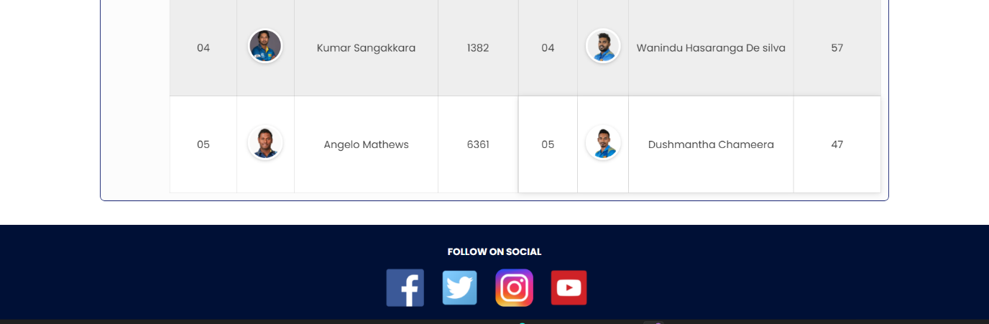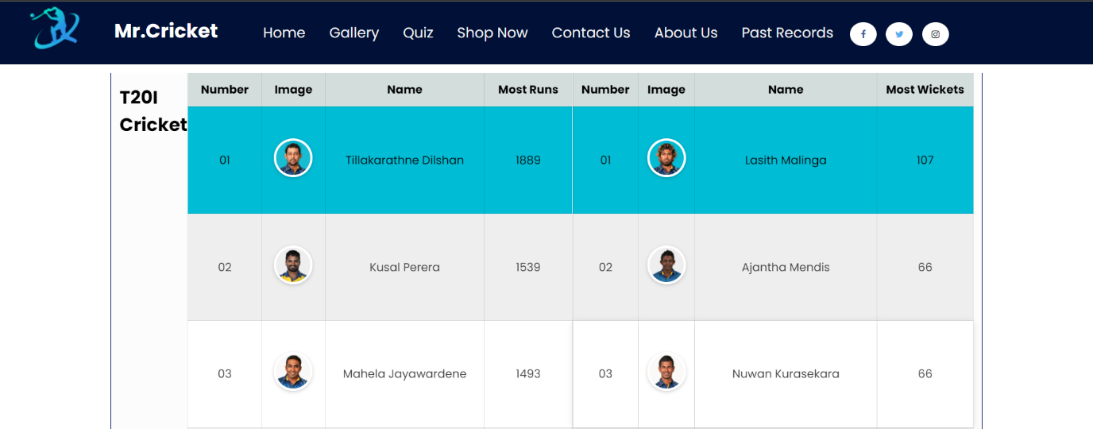

**Additional One**

**Figure 29 Additional one**

3. Webpage Validation Statement

I make certain that all three web pages I develop function properly. The appropriate screenshot will be included in Appendix C.

4. Janet

JANET is highspeed computer network that links education and research community in UK. This enables institute to improve the student experience with rich learning research and helps the students to stay on the right track In the JANET network there are some policies to follow as an organization or institute that uses its network

those are 1. Eligibility Policy

2. Acceptable Use Policy

3. Security Policy these policies make sure that all the organization and institute keeping their network secure

I oversaw ensuring that the quiz and student information adhered to Janet Policies and Legal Requirements. Our website name " Mr. Cricket" is a unique name that is not being used by anybody else, thus no copy right issues will arise. Our website's logo is one-of-a-kind, and it, along with the website name, is not found anywhere else on the internet, thus any developments are subject to Janet Regulations.

The quiz contains certain questions that were obtained from non-copyright cricket question sites, thus it's completely legal and there's no problem with utilizing questions and answers from non-copyright sites. I utilized Google Fonts on both of my pages, and I've listed it as a reference that I've used. So, by utilizing Google Fonts and open-source icons, I have not committed any unlawful acts. I didn't use any material from the internet to create my web pages; all the descriptions are my own creations.

References

<https://www.w3schools.com/tags/att_input_type_submit.asp>

<https://www.w3schools.com/tags/att_input_type_radio.asp>

<https://colorhunt.co/palette/0513672d31fa5d8bf4dff6ff>

<https://www.w3schools.com/howto/howto_css_image_overlay_slide.asp>

<https://community.jisc.ac.uk/library/janet-services-documentation/janet-policies-and-legal-requirements>

<https://www.w3schools.com/tags/tag_div.asp>

Appendices

## Appendix A: Code

File Name: quiz.html

Code

<!DOCTYPE html>

<html lang="en">

<head>

    <meta charset="UTF-8">

    <title>Quiz</title>

    <link rel="stylesheet" href="quiz.css">

    <link rel="preconnect" href="https://fonts.googleapis.com">

    <link rel="preconnect" href="https://fonts.gstatic.com" crossorigin>

    <link href="https://fonts.googleapis.com/css2?family=Poppins:ital,wght@0,100;0,400;0,500;0,600;0,700;0,800;0,900;1,100;1,200;1,300;1,400;1,500;1,600;1,700;1,800;1,900&display=swap" rel="stylesheet">

</head>

<body id="body">

    <!--Multiple-choice quiz-->

    <div id="home-area" class='start-question-box'>

        <h3>Welcome to the Quiz</h3><!--guidelines of the quize -->

        <br>

        <p>Total number of questions:<span class='total-questions'>10</span></p>

        <p>You have only 60 sec to think.</p>

        <p>The time will start after you press the start button</p>

        <p>Good Luck</p>

        <button type='button' class='btn' onclick="showQuestions()">Start</button>

    </div>

    <!--10 questions included-->

    <div id="questions-area" hidden>

        <!--question 1-->

        <div class='question-box' >

            <p class='question-number'>Question 1 </p>

            <p class='question'>01.Which year was Sri Lankan first Asian Cup victory away from home?</p>

            <input type="radio" class='answer' name="answer1" value="0">1986<br>

            <input type="radio" class='answer' name="answer1" value="1">2001<br>

            <input type="radio" class='answer' name="answer1" value="2">2013<br>

            <input type="radio" class='answer' name="answer1" value="3">2008<br>

        </div>

        <!--question 2-->

        <div class='question-box'>

            <p class='question-number'>Question 2 </p>

            <p class='question'>02.Which Sri Lanka won player of the series award in the 1996 ICC world cup?</p>

            <input type="radio" class='answer' name="answer2" value="0">Chaminda Vas<br>

            <input type="radio" class='answer' name="answer2" value="1">Aravinda silva<br>

            <input type="radio" class='answer' name="answer2" value="2">Sanath Jayasuriya<br>

            <input type="radio" class='answer' name="answer2" value="3">Muttiah Muralidharan<br>

        </div>

        <!--question 3-->

        <div class='question-box'>

            <p class='question-number'>Question 3 </p>

            <p class='question'>03.Who was sri lankan first test captain?</p>

            <input type="radio" class='answer' name="answer3" value="0">Chaminda vas<br>

            <input type="radio" class='answer' name="answer3" value="1">Bandula warnapura<br>

            <input type="radio" class='answer' name="answer3" value="2">Sanath Jayasuriya<br>

            <input type="radio" class='answer' name="answer3" value="3">Muttiah Muralidharan<br>

        </div>

        <!--question 4-->

        <div class='question-box'>

            <p class='question-number'>Question 4 </p>

            <p class='question'>04.Who was the first Sri Lankan bowler to take a test hat-trick?</p>

            <input type="radio" class='answer' name="answer4" value="0">Chaminda vas<br>

            <input type="radio" class='answer' name="answer4" value="1">Nuwan Zoysa<br>

            <input type="radio" class='answer' name="answer4" value="2">Sanath jayasuriya<br>

            <input type="radio" class='answer' name="answer4" value="3">Muttiah Muralidharan<br>

        </div>

        <!--question 5-->

        <div class='question-box'>

            <p class='question-number'>Question 5 </p>

            <p class='question'>05.Which Sri Lankan family produced three test-playing brothers?</p>

            <input type="radio" class='answer' name="answer5" value="0">De silva<br>

            <input type="radio" class='answer' name="answer5" value="1">Ranatunga<br>

            <input type="radio" class='answer' name="answer5" value="2">Jayasuriya<br>

            <input type="radio" class='answer' name="answer5" value="3">Jayawardhana<br>

        </div>

        <!--question 6-->

        <div class='question-box'>

            <p class='question-number'>Question 6 </p>

            <p class='question'>06.What is the oldest cricket club in Sri Lanka?</p>

            <input type="radio" class='answer' name="answer6" value="0">Galle cricket club<br>

            <input type="radio" class='answer' name="answer6" value="1">Colombo cricket club<br>

            <input type="radio" class='answer' name="answer6" value="2">bloomfield cricket club<br>

            <input type="radio" class='answer' name="answer6" value="3">Sinhalese Sports club<br>

        </div>

        <!--question 7-->

        <div class='question-box'>

            <p class='question-number'>Question 7 </p>

            <p class='question'>07.Sri Lankan first official international match was played in 1975.</p>

            <input type="radio" class='answer' name="answer7" value="0">True<br>

            <input type="radio" class='answer' name="answer7" value="1">False<br>

        </div>

        <!--question 8-->

        <div class='question-box'>

            <p class='question-number'>Question 8 </p>

            <p class='question'>08.Which Sri Lankan cricketer captained the team the most times?</p>

            <input type="radio" class='answer' name="answer8" value="0">Mahela Jayawardana<br>

            <input type="radio" class='answer' name="answer8" value="1">Arjuna Ranathunga<br>

            <input type="radio" class='answer' name="answer8" value="2">Thilakaratne Dilshan<br>

            <input type="radio" class='answer' name="answer8" value="3">Sanath Jayasuriya<br>

        </div>

        <!--question 9-->

        <div class='question-box'>

            <p class='question-number'>Question 9 </p>

            <p class='question'>09.Which player scored Sri Lankan first T20I century?</p>

            <input type="radio" class='answer' name="answer9" value="0">Mahela Jayawardana<br>

            <input type="radio" class='answer' name="answer9" value="1">Arjuna Ranathunga<br>

            <input type="radio" class='answer' name="answer9" value="2">Thilakaratne Dilshan<br>

            <input type="radio" class='answer' name="answer9" value="3">Sanath Jayasuriya<br>

        </div>

        <!--question 10-->

        <div class='question-box'>

            <p class='question-number'>Question 10 </p>

            <p class='question'>10.who scored Sri Lankan first test century?</p>

            <input type="radio" class='answer' name="answer10" value="0">Duleep Mendis<br>

            <input type="radio" class='answer' name="answer10" value="1">Ranjan Madugalla<br>

            <input type="radio" class='answer' name="answer10" value="2">Sidath Wettimuny<br>

            <input type="radio" class='answer' name="answer10" value="3">Sanath Jayasuriya<br>

        </div>

        <div class="question-box">

            <button type="button" class="btn" id="toTop" onclick="goToTop()">Back to Top</button>

            <button type="submit" class="btn" onclick="showResults()">Submit</button>

        </div>

    </div>

    <!-- Results Area-->

    <div id="results-area" class='results-box' hidden>

        <h1 class='results'>Results</h1>

        <p class='total' id='total'></p>

        <table>

            <tr>

                <th>Question Number</th>

                <th>Correct Answer</th>

                <th>Your Answer</th>

            </tr>

            <tr>

                <td>Question 01</td>

                <td>3</td>

                <td id="q1"></td>

            </tr>

            <tr>

                <td>Question 02</td>

                <td>2</td>

                <td id="q2"></td>

            </tr>

            <tr>

                <td>Question 03</td>

                <td>1</td>

                <td id="q3"></td>

            </tr>

            <tr>

                <td>Question 04</td>

                <td>2</td>

                <td id="q4"></td>

            </tr>

            <tr>

                <td>Question 05</td>

                <td>1</td>

                <td id="q5"></td>

            </tr>

            <tr>

                <td>Question 06</td>

                <td>1</td>

                <td id="q6"></td>

            </tr>

            <tr>

                <td>Question 07</td>

                <td>0</td>

                <td id="q7"></td>

            </tr>

            <tr>

                <td>Question 08</td>

                <td>1</td>

                <td id="q8"></td>

            </tr>

            <tr>

                <td>Question 09</td>

                <td>0</td>

                <td id="q9"></td>

            </tr>

            <tr>

                <td>Question 10</td>

                <td>1</td>

                <td id="q10"></td>

            </tr>

        </table>

    </div>

    <div class="editpage">

        <a href="Maduri.html"><img src="Picsart_22-03-24_15-15-08-758.jpg"alt="Page editor icon" width="125px" height="125px"></a>

    </div>

    <script>

        function getRadioValue(radioArray) {

            var i;

            for(i=0; i<radioArray.length; i++) {

                if(radioArray[i].checked) {

                    return radioArray[i].value;

                }

            }

            return -1;

        }

        function timer() {

            var setTimer = setInterval(showResults, 60000);

        }

        function goToTop() {

            document.body.scrollTop = 0;

            document.documentElement.scrollTop = 0;

        }

        function reviewAnswers() {

            var homeBox = document.getElementById("home-area").hidden = true;

            var questionBox = document.getElementById("questions-area").hidden = false;

            var resultsBox = document.getElementById("results-area").hidden = true;

            document.body.style.backgroundColor = "#63656a";

        }

        function showQuestions() {

            var homeBox = document.getElementById("home-area").hidden = true;

            var questionBox = document.getElementById("questions-area").hidden = false;

            var resultsBox = document.getElementById("results-area").hidden = true;

            timer();

        }

        function showResults () {

            var homeBox = document.getElementById("home-area").hidden = true;

            var questionBox = document.getElementById("questions-area").hidden = true;

            var resultsBox = document.getElementById("results-area").hidden = false;

            var selectedAnswers = [];

            for(let j = 0; j < 10; j++) {

                var name = "answer" + (j+1);

                var allAnswers = [];

                allAnswers = document.getElementsByName(name);

                var selectedAnswer = getRadioValue(allAnswers);

                selectedAnswers[j] = selectedAnswer;

            }

            let score = 0;

            const correctAnswers = [3,2,1,2,1,1,0,1,0,1];

            for(let i = 0; i < selectedAnswers.length; i++) {

                var id = "q" + (i+1);

                if(selectedAnswers[i] == correctAnswers[i]) {

                    score += 2;

                    document.getElementById(id).innerHTML = "correct";

                } else {

                    score -= 1;

                    document.getElementById(id).innerHTML = "incorrect";

                }

            }

            document.getElementById("total").innerHTML = "Your score is " + score;

            document.body.style.backgroundColor = "yellow";

            if(score <= 4) {

                document.body.style.backgroundColor = "#ff0000";

            } else if(score > 16){

                document.body.style.backgroundColor = "#00ff00";

            }

        }

    </script>

</body>

</html>

File Name: quiz.css

Code

::-webkit-scrollbar {display: none;}

#body{

    min-height: 100vh;

    width: 100%;

    background-position: center;

    background-size: cover;

    position: relative;

    font-family: 'Poppins', sans-serif;

}

.start-question-box {

    max-width: 600px;

    margin: 40px auto;

    padding: 100px;

    border-radius: 40px;

    background-color: #DFF6FF;

}

.start-question-box h3 {

    font-size: 50px;

    color: #051367;

    font-weight: 700;

    margin-bottom: 15px;

    line-height: 25px;

    text-align: center;

}

.start-question-box p {

    font-size: 20px;

    color: #000000;

    font-weight: 600;

    margin-bottom: 10px;

    line-height: 22px;

    text-align: center;

}

.start-question-box p span {

    font-weight: 600;

}

.start-question-box .btn {

    margin-top: 20px;

}

.btn{

    padding: 16px 47px;

    background-color: #051367;

    color: #ffffff;

    border: none;

    font-size: 16px;

    border-radius: 10px;

}

.question-box{

    max-width: 700px;

    background-color: #DFF6FF;

    margin: 40px auto;

    padding: 30px;

    border-radius: 20px;

}

.question-box .question-number{

    font-size: 19px;

    color: black;

    font-weight: 800;

    border-bottom: 1px solid #cccccc;

    padding-bottom: 10px;

    line-height: 25px;

    text-align: center;

}

.question-box .question {

    font-size: 22px;

    color: #000000;

    line-height: 28px;

    padding: 20px 0;

    margin: 0;

    font-weight: 400;

}

.question-box .btn {

    margin-right: 20px;

}

.results-box{

    max-width: 700px;

    background-color: #ffffff;

    margin: 40px auto;

    padding: 30px;

    border-radius: 10px;

    text-align: center;

}

.results-box .results{

    margin-left: 0px;

    font-size: 36px;

    line-height: 42px;

    color: #1167b1;

}

.results-box table {

    width: 100%;

    border-collapse: collapse;

    margin: 30px 0;

}

.results-box table th, .results-box table td {

    border: 1px solid #cccccc;

    padding: 8px 15px;

    font-weight: 500;

    color: #000000;

    width: 50%;

    text-align: left;

    font-size: 18px;

}

.results-box .total {

    font-weight: 500;

    font-size: 18px;

}

.editpage {

    position: relative;

    text-align-last: right;

    right: 3%;

    top: 3vh;

    margin-top: 10px;

  }

  .editpage img{

    position: relative;

    margin: 0px;

    text-align-last: right;

    right: 1%;

    border-radius: 30px;

  }

  .editpage img:hover {

    opacity: 0.7;

  }

Filename: SD.html

Code

<!DOCTYPE html>

<html lang="en">

    <head>

        <title> Student Details</title>

        <link href="SD.CSS" rel="stylesheet">

        <link rel="preconnect" href="https://fonts.googleapis.com">

        <link rel="preconnect" href="https://fonts.gstatic.com" crossorigin>

        <link href="https://fonts.googleapis.com/css2?family=Poppins:ital,wght@0,100;0,400;0,500;0,600;0,700;0,800;0,900;1,100;1,200;1,300;1,400;1,500;1,600;1,700;1,800;1,900&display=swap" rel="stylesheet">

    </head>

    <body>

        <div class="icon" align="center">

            <h1 id="studentHeading">Student Details</h1>

            <!-- Group Members Details-->

            <div id="students">

              <!-- Student 1-->

                <div class="studentBox">

                    <div class="imgArea">

                     <img class="studentPhoto" src="student1.jpeg" alt="chamelee">

                       <div class="studentLayer">

                         <p class="studentNum">Student 1</p>

                         <p class="studentDesc">Chamelee Gurusinghe</p>

                         <p class="studentDesc">w1870582</p>

                         <p class="studentDesc">20200522</p>

                        </div>

                   </div>

                 </div>

                 <!-- Student 2-->

                 <div class="studentBox">

                    <div class="imgArea">

                     <img class="studentPhoto" src="student2.jpeg" alt="maneesha">

                       <div class="studentLayer">

                         <p class="studentNum">Student 2</p>

                         <p class="studentDesc">Maneesha shehara</p>

                         <p class="studentDesc">w1870581</p>

                         <p class="studentDesc">20200490</p>

                        </div>

                   </div>

                 </div>

                 <!-- Student 3-->

                 <div class="studentBox">

                    <div class="imgArea">

                     <img class="studentPhoto" src="student3.jpeg" alt="maduri">

                       <div class="studentLayer">

                         <p class="studentNum">Student 3</p>

                         <p class="studentDesc">Maduri Dhananjani</p>

                         <p class="studentDesc">w1870614</p>

                         <p class="studentDesc">20200652</p>

                        </div>

                   </div>

                 </div>

                 <!-- Student 4-->

                 <div class="studentBox">

                    <div class="imgArea">

                     <img class="studentPhoto" src="student4.jpeg" alt="praveen">

                       <div class="studentLayer">

                         <p class="studentNum">Student 4</p>

                         <p class="studentDesc">Praveen Navanjana</p>

                         <p class="studentDesc">w1870590</p>

                         <p class="studentDesc">20200877</p>

                        </div>

                   </div>

                </div>

            </div>

        </div>

        <div class="editpage">

          <a href="Maduri.html"><img src="Picsart_22-03-24_15-15-08-758.jpg"alt="Page editor icon" width="125px" height="125px"></a>

      </div>

    </body>

</html>

Filename: SD.CSS

Code

::-webkit-scrollbar {display: none;}

body{

    overflow-x: hidden;

    background-color: #28282B;

    font-family: 'Poppins', sans-serif;

}

h1{font-size:25px;

   color:rgb(32, 31, 31);}

#studentHeading{

    color:#ffff;

    font-size:50px;

    text-align: center;

}

.studentBox {

    margin-left:40px;

    width: 300px;

    height: 350px;

    padding:10px;

    border-radius:20px;

    border: 6px solid black;

}

.studentNum{

    text-align:center;

    font-size:25px;

    font-weight:bold;

    border-color:#b1aeae;

    border-radius:none;

    width:130px;

}

.imgArea {

   position: relative;

   width: 300px;

   height: 350px;

   border-radius:20px;

}

.studentLayer {

    width: 0px;

    height: 350px;

    background: rgba(0,0,0, 0.5);

    position: absolute;

    top: 0;

    overflow: hidden;

    transition: 0.7s ease;

    border-radius:15px;

}

.studentDesc {

    transition: .2s;

    overflow:hidden;

    width:300px;

    font-size:20px;

    background-color:rgba(178,190,181, 0.5);

}

.imgArea:hover .studentLayer{

    width:300px;

}

p {

    color: white;

    font-size: 25px;

}

img{

    border-radius:15px;

}

#students{

    margin-top:70px;

    display:grid;

    grid-template-columns:auto auto auto auto;

}

.studentPhoto{

    height:350px;

    width:300px;

}

.editpage {

    position: relative;

    text-align-last: right;

    right: 3%;

    top: 3vh;

    margin-top: 10px;

  }

.editpage img{

    position: relative;

    margin: 0px;

    text-align-last: right;

    right: 1%;

  }

.editpage img:hover {

    opacity: 0.7;

  }

Filename: Maduri.html

Code

<!DOCTYPE html>

<html>

    <head>

        <meta charset="UTF-8">

        <title> Page Editor</title>

        <link rel="stylesheet" href="Maduri.css">

        <link rel="preconnect" href="https://fonts.googleapis.com">

        <link rel="preconnect" href="https://fonts.gstatic.com" crossorigin>

        <link href="https://fonts.googleapis.com/css2?family=Poppins:ital,wght@0,100;0,400;0,500;0,600;0,700;0,800;0,900;1,100;1,200;1,300;1,400;1,500;1,600;1,700;1,800;1,900&display=swap" rel="stylesheet">

    </head>

    <body>

        <br>

        <div class="row">

            <div class="colum">

                <div class="card">

                    <h1  align="center"> <b>Maduri Dhananjani</b> </h1>

                    <img class="maneesha" src="student3.jpeg" alt="Maduri" width="30%">

                    <div class="container">

                    <p class="title"><b> Role Number : Student 3</p>

                    <p class="title"> Uow Number : w1870614</p>

                    <p class="title"> IIT Number : 20200652</p>

                    <p class="description" align="center"> Tasks I completed : I created the Quze, Student Details and page editors webpage.<br> And, I disigned home page and additional page with my group members.</p></b>

                    </div>

                </di>

                </div>

            </div>

        </div>

    </body>

</html>

Filename: Maduri.css

Code

::-webkit-scrollbar {display: none;}

html {

    box-sizing: border-box;

  }

body{

    font-family: 'Poppins', sans-serif;

    background-color:  #28282B;

    align-items: center;

    color: white;

}

  *, *:before, *:after {

    box-sizing: inherit;

  }

  .maneesha{

    border-radius: 30px;

    padding-top:12px ;

    padding-right: 12px;

    padding-bottom: 12px;

    padding-left: 12px;

  }

  .column {

    float: left;

    width: 33.3%;

    margin-bottom: 16px;

    padding: 10px 10px;

  }

  @media screen and (max-width: 650px) {

    .column {

      width: 100%;

      display: block;

    }

  }

  .card {

    box-shadow: 30px 30px 30px 30px rgba(0, 0, 0, 0.2);

    background-color:#28282B;

    border-radius: 20px;

    border-style: solid;

    border-color: #001036;

  }

  .container {

    padding: 0 16px;

  }

  .container::after, .row::after {

    content: "";

    clear: both;

    display: table;

  }

  .title {

    color: white;

    font-size: 25px;

  }

  .description {

    font-size: 25px;

  }

  .row{

      text-align: center;

  }

  .h2{

      text-align: center;

  }

## Appendix B: Screenshots

Quiz



**Figure 30 Quiz 1**

**Quiz 1**

**Quiz 2**

**Figure 31 Quiz 2**



**Quiz 3**

**Figure 32 Quiz 3**



**Quiz 4**

**Figure 33 Quiz 4**



**Quiz 5**

**Figure 34 Quiz 5**



**Quiz 6**

**Figure 35 Quiz 6**



**Quiz 7**

**Figure 36 Quiz 7**



**Quiz 7**

**Figure 37 Quiz 8**



**Quiz 8**

**Figure 38 Quiz 9**



**Quiz 9**

**Figure 39 Quiz 10**

Student Details



**Student Details 1**

**Figure 40 Student Details 1**

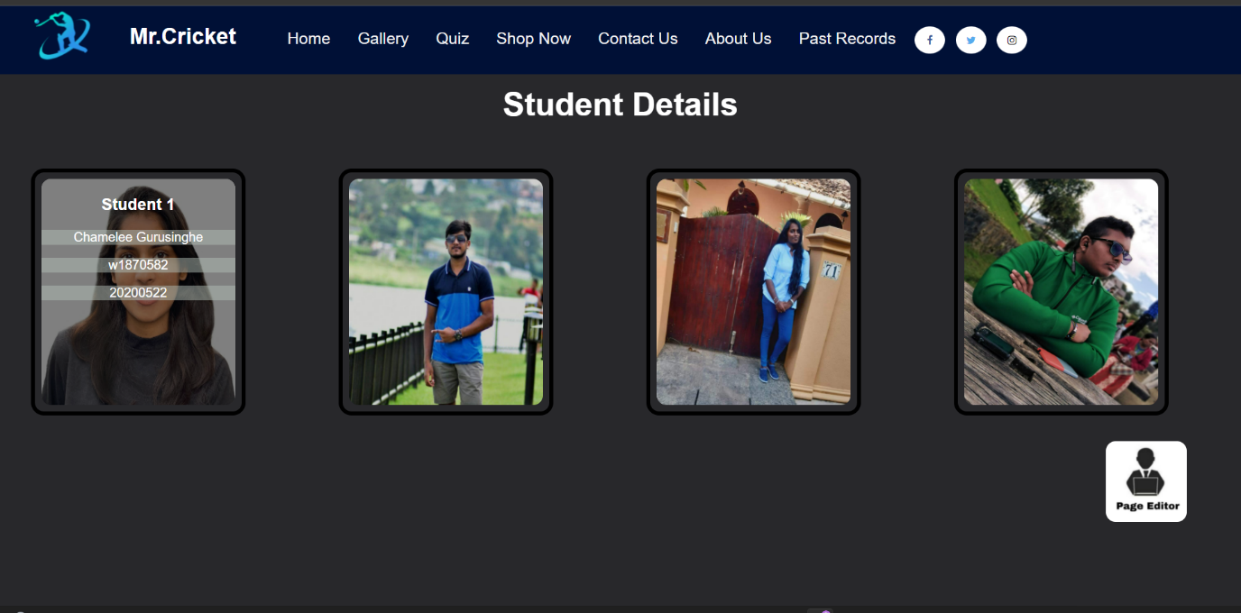

**Student Details 2**

**Figure 41 Student Details 2**



**Student Details 3**

**Figure 42 Student Details 3**

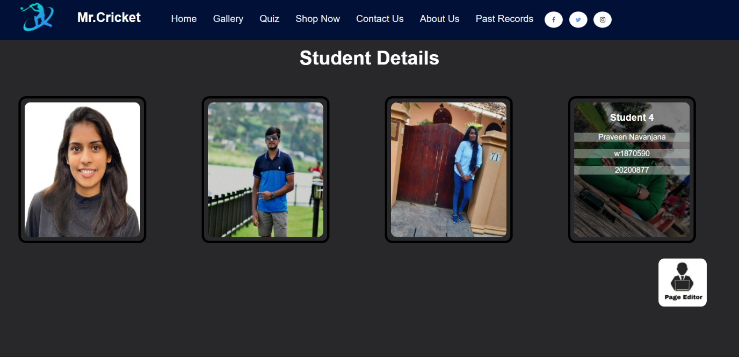

**Student Details 4**

**Figure 43 Student Details4**

Page Editor



**Page Editor**

**Figure 44 Page Editor**

Main Page

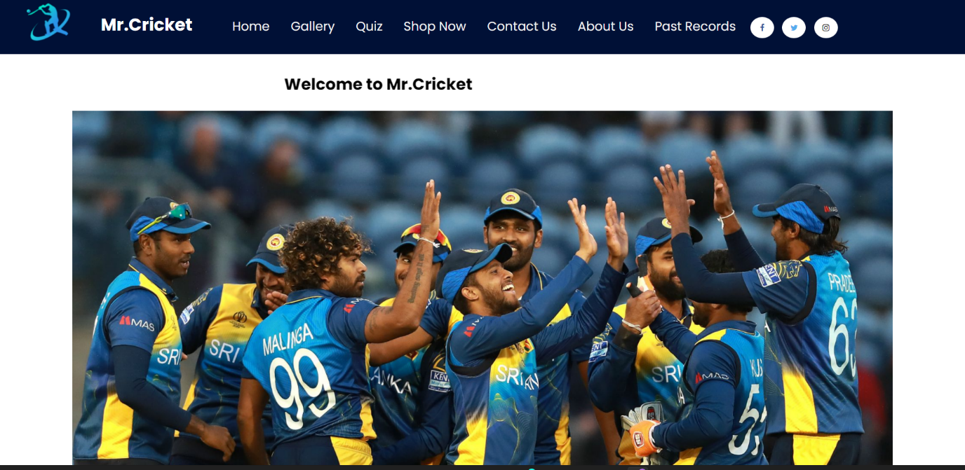

**Main Page 1**

**Figure 45 Main Page 1**

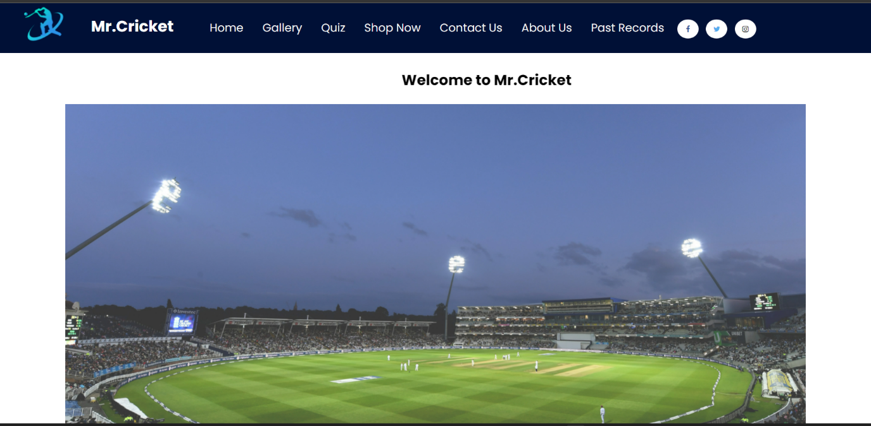

**Main Page 2**

**Figure 46 Main Page 2**

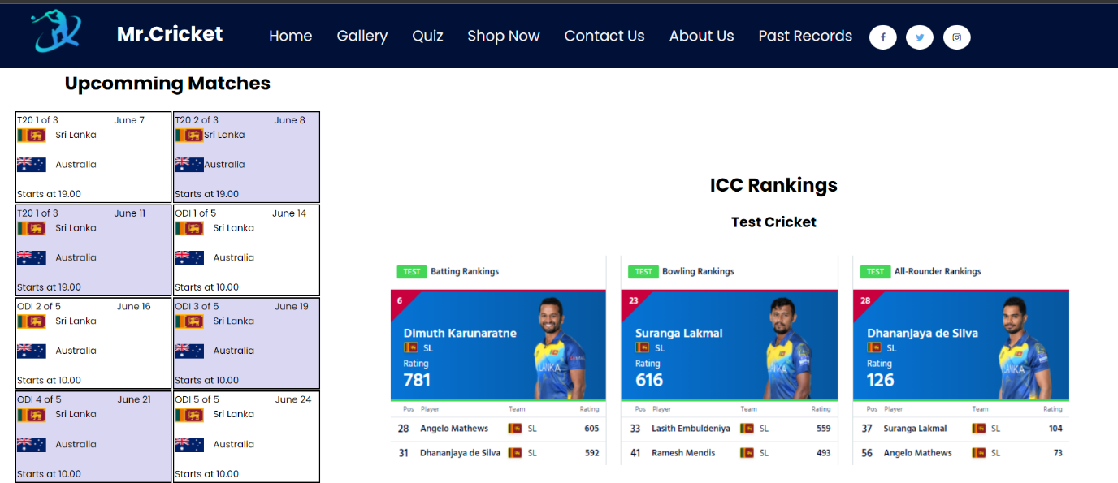

**Main Page 3**

**Figure 47 Main Page 3**

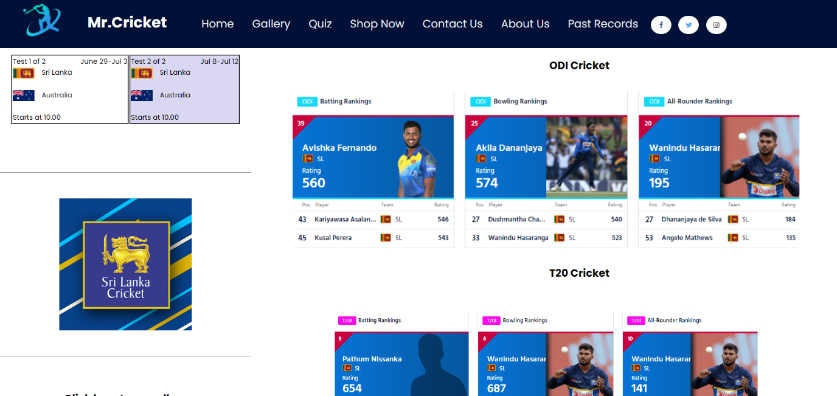

**Main Page 4**

**Figure 48 Main Page 4**

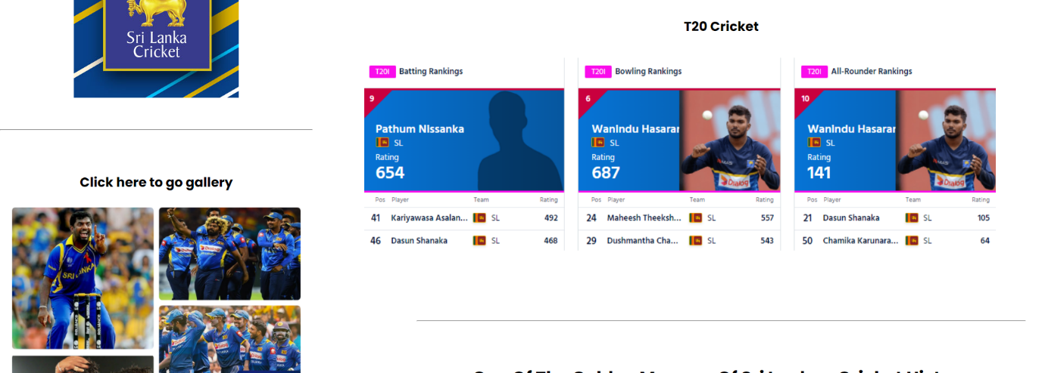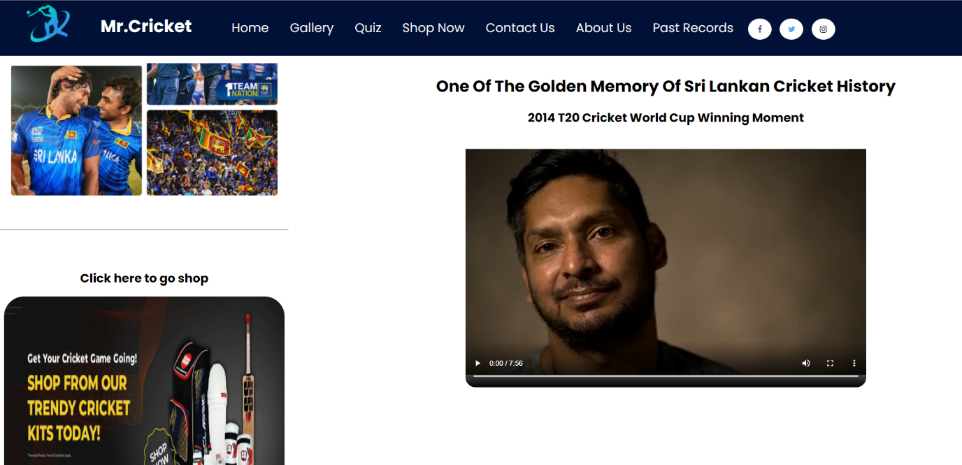

**Figure 49 Main Page 6**

**Main Page 6**

**Main Page 5**

**Figure 50 Main Page 5**

## Appendix C: Screenshots - Webpage Validation Evidence

Quiz.html

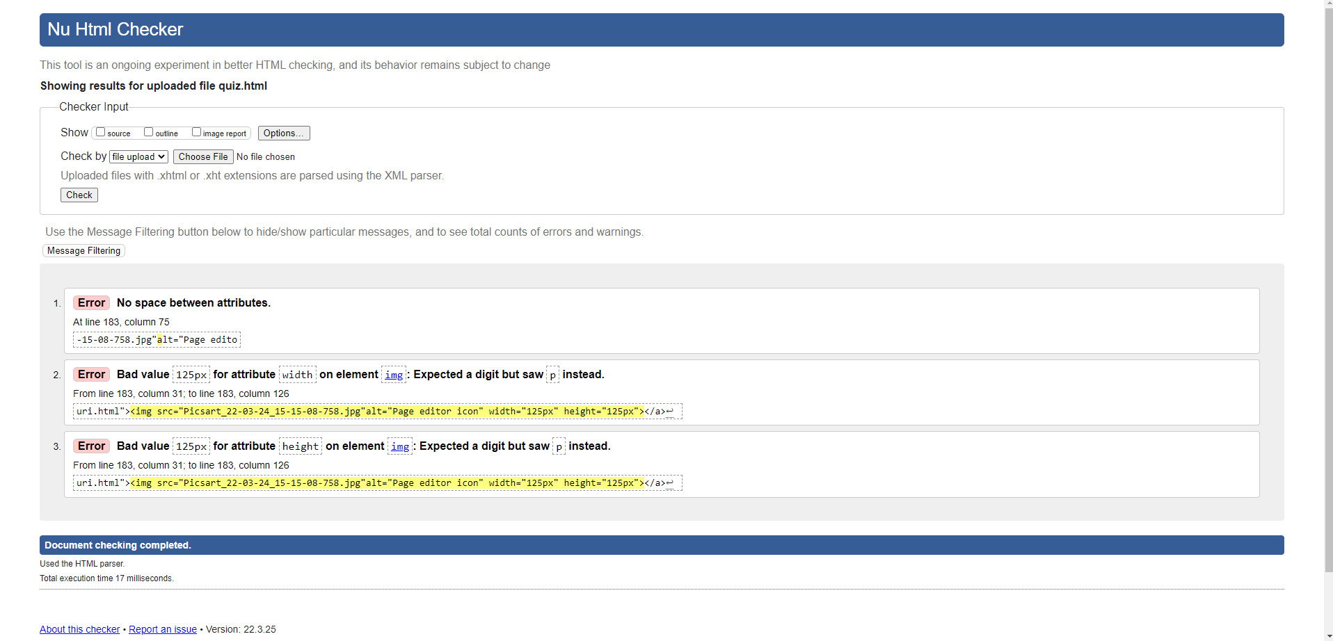

**Validator 1**

**Figure 51 Validator 1**

SD.html

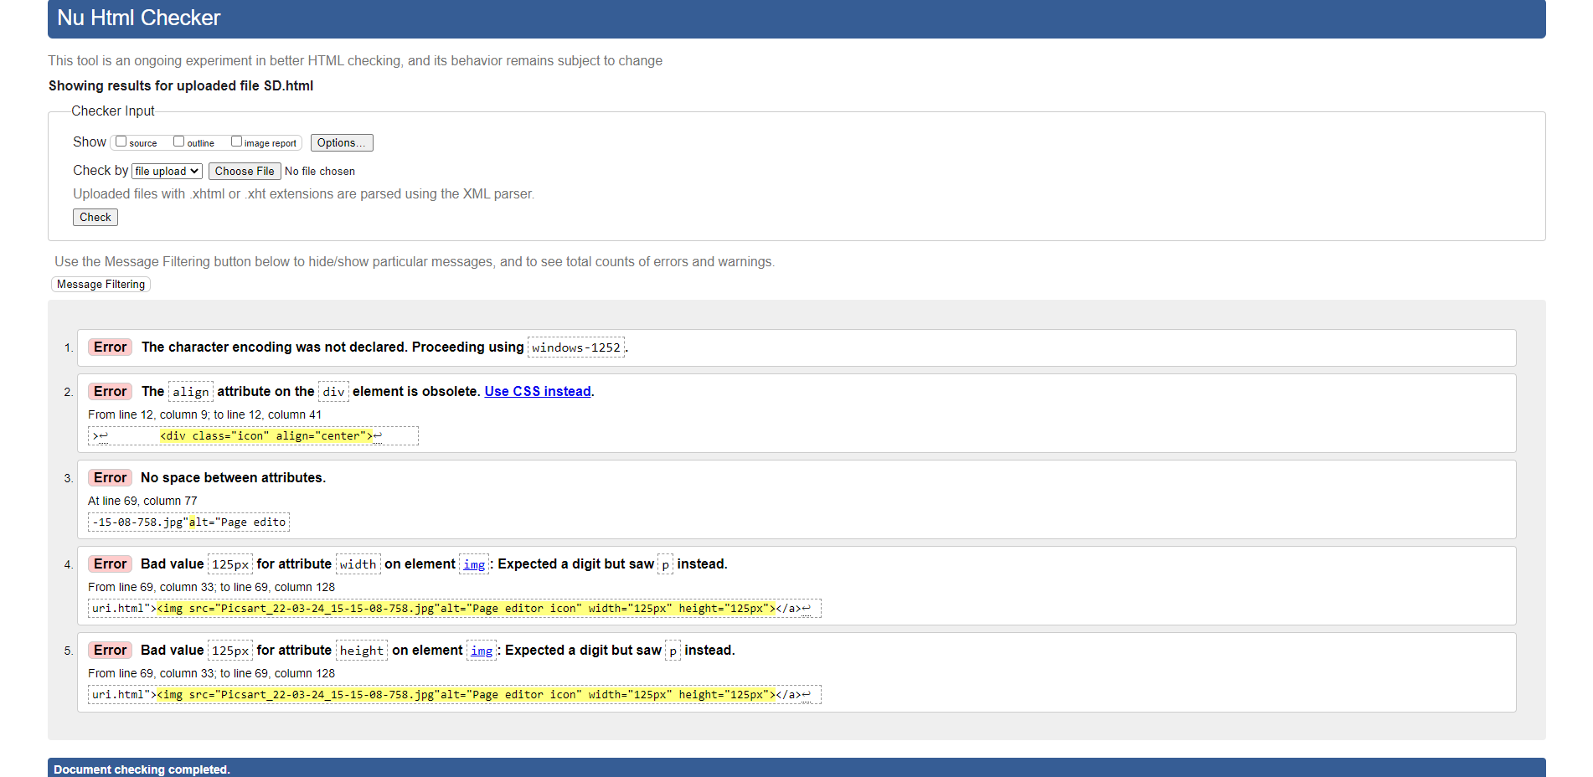

**Validator 2**

**Figure 52 Validator 2**

## Appendix D: Individual Statement

| Student Name: | P.A.Maduri Dhananjani | Student Id: | 20200652 |
| --- | --- | --- | --- |
| State what tasks you carried out in the project. | | | |
| 1. Quiz 2. Student details 3. Editor page | | | |
| State what you enjoyed and did not enjoy about teamwork. | | | |
| I liked working as part of a team, and this is my first time developing a website. As a result, I am really pleased with the work of my group members.  I should also remark that the team is really well led by the group leader. | | | |
| State what you learnt about teamwork. | | | |
| Everyone has a responsibility to work hard in order to achieve a successful assignment. | | | |
| State what skills you gained/learnt from undertaking the project. | | | |
| I developed my abilities to work mostly in CSS, but also in HTML and JAVASCRIPT. | | | |
| State any strengths about yourself that emerged whilst undertaking the project. | | | |
| really love to do web developments. So, in my role, my favorite part is the Student details page. Because when I was designing it I found so many things works in CSS. | | | |
| State any weaknesses about yourself that emerged whilst undertaking the project. | | | |
| Sometimes it was difficult to add java script parts. | | | |
| State how you would do things better if you were to undertake the project again. | | | |
| First and foremost, I have a firm grasp of the tasks at hand. I prioritize my tasks and strive to complete them well. It is a privilege for me to contribute to a team project and to do so properly. I'm hoping to finish my teamwork and talk with my teammates. | | | |
| Additional general or project-specific comments: | | | |
| We may accomplish a lot in our lives by participating in team activities. I met several of my pals at iit while conducting the Working with Data Group activity. | | | |